Mutt Strut 2023
Sherlock Bones and other
Dashing & Daring Dog Detectives.

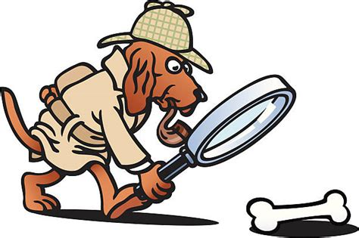
- When—Sunday September 10, 2023, 12:00 Noon – 3:00 PM (Rain or Shine)

- Where—Silver Hill Technology Park, Route 88 North, Newark, NY

- Why—To help support your local animal shelter and all its furry friends.

- Who—YOU - With or without your Dog (Shelter dogs will be available to walk)

- How—Have family, friends, co-workers, neighbors, relatives, classmates, and anyone else you can think of to sponsor you for the Mutt Strut by donating money to HSWC. The three people raising the most money will receive a prize.

- Special Drawing – Bring one of the following items to receive a ticket:
Cat Litter, Postage stamps, 55 gal. Construction bags, Paper towels & Paper plates.

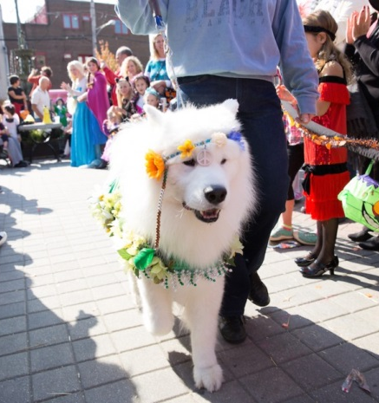
THIS YEAR’S THEME IS: Sherlock bones looking for clues.
PRIZES AWARDED FOR 1st, 2nd, & 3rd PLACE PEOPLE WHO RAISE THE MOST MONEY
PRIZES FOR BEST DRESSED PET & HUMAN!
There is a lot to do

Enter 50/50 raffle, Silent Auction, grab some lunch, win a Door Prize and much more.
Live music, Wine Tasting, and vendors.
Registration is a must! Pre-registration is preferred and will guarantee you a t-shirt and goodie bag. Registration Forms are available at the following locations:
Local Area Veterinary Offices, HSWC Shelter
More Information Call (315) 946-3389

